|  |  |
| --- | --- |
| Prepared | Navya S |
| Reviewed | Gunasekar K |
| Category | Article |

|  |  |  |  |  |
| --- | --- | --- | --- | --- |
| Document Identification | | | | |
| Version | Status | | | Date (DD-MM-YYYY) |
| 1.0 | Initial draft | | | 12-12-2019 |
| 2.0 | Final | | | 13-12-2019 |
|  | | | | |
| Global SAP Support | |  | Date (DD-MM-YYYY) | |

**Problem description**

In transaction ME21N/ME22N, when user tries to change the order unit to a different UOM, it does not get changed and it shows the same UOM

**Case 1:**

**Reproducing the Issue**

**PO Creation:**

1. Enter transaction code ME21N
2. Choose PO Docuement type: Z001, Vendor, Purch. Org, Pur. Grp in PO Header Level.
3. Enter Material code “ **100000011486**“, PO Quantity, Price and plant in PO item level.
4. The order unit picked is KG, user tries to change it to MT

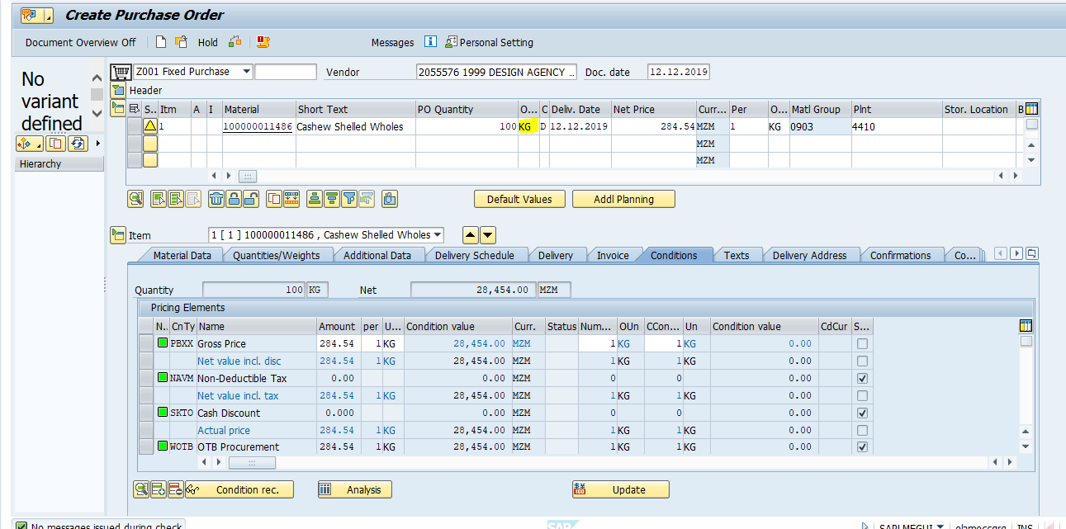

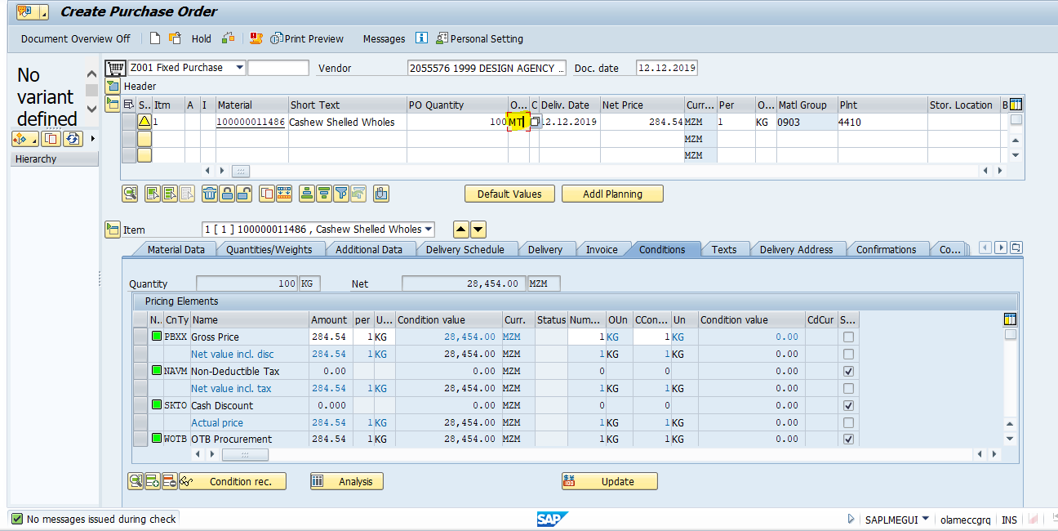

1. When he changes it to MT and clicks on enter , it shows KG itself



**Cause**

The order unit whichever user is trying to change is not maintained in Inforecord -General data view or In Mater master Purchasing view

**Resolution**

User has to contact MDM TEAM to maintain the order unit in Inforecord and in Material master data

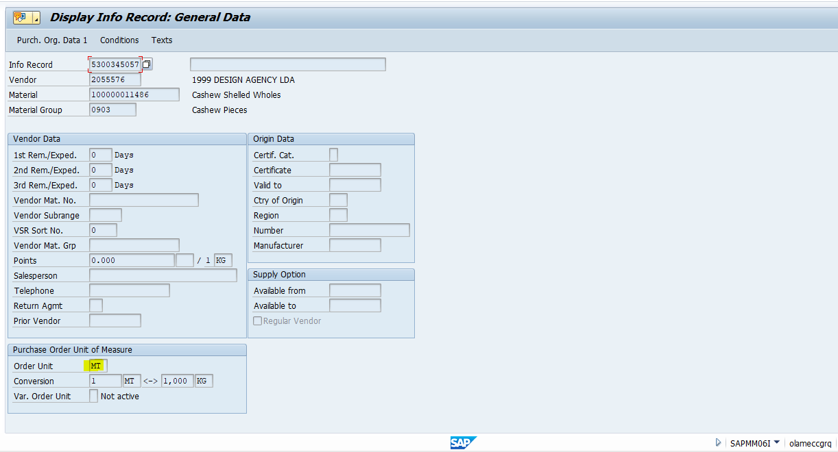



Once maintained, user will be able to save the PO with MT as the order unit

